**Xiang Pan 潘翔**

**1900941520**

[**hover@hust.edu.cn**](mailto:hover@hust.edu.cn)

# Q1 $I_{ext}$ = current = 4, 7, and 14

I change the current and got the follow images. We can get the conclusion that there is a threshold for the HH model, with and when the currents up to the threshold, the shape of spike is almost the same. If the current value is higher, and the frequence will be higher.

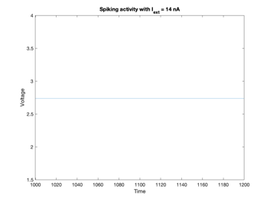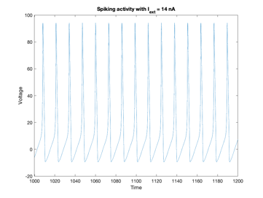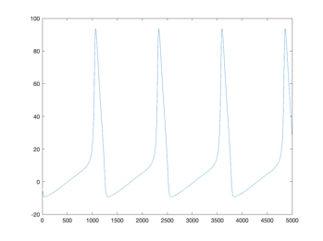

**Image 1.1 hh_func(current,noise):(4,0) (7,0) (14,0) and the** **spike image after** **amplified**

# Q2 frequency-current (f-I) curve

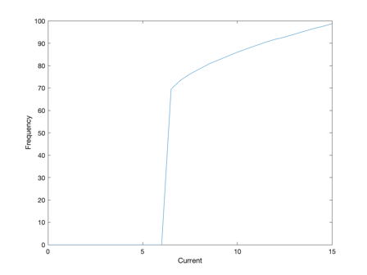

**Image 2.1 f-I curve of (7,0)**

# Q3 add noise

When we add some noise in the current, we can get the images as follow.

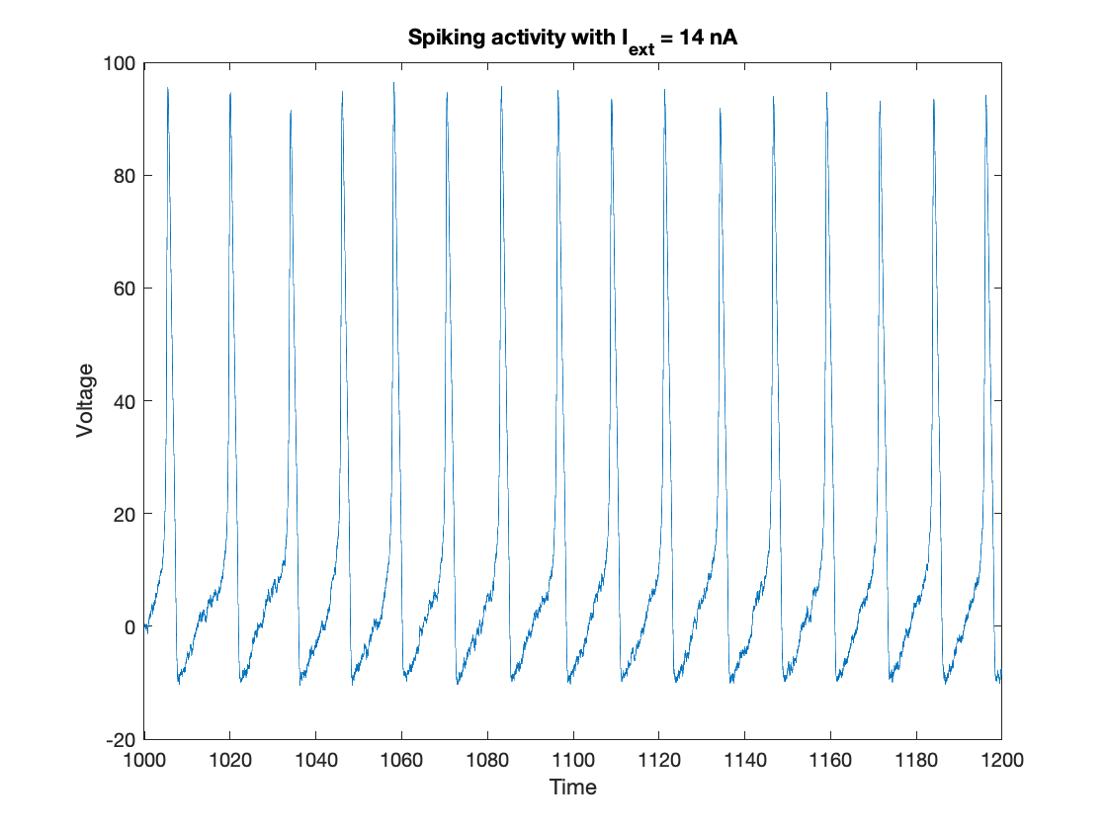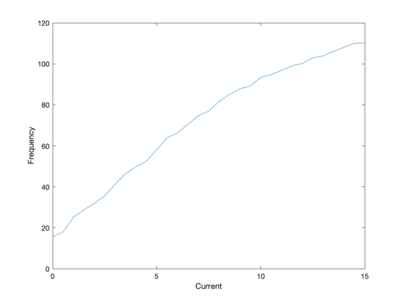

**Image 3.1 spike image and f-I curve with the input of (i,20) when noise added on $I_{ext}$**

Conclusion: The noise may disturb the original function and the noise may made the spike appear more early and also reduce the threshold(minimum firing rate) of F-I curve.

# QC: The Robust of the Neuronal Model

After the learning, we know that the Neuronal Model’s F-I curve is just like the activation function in Mache Learning. In ML, we have a lot of activation function, and the characteristics are crucial in designing the ML model. Such as ELU is more robust than others such as sigmoid etc. So I try to measure the threshold and robust of F-I curve.

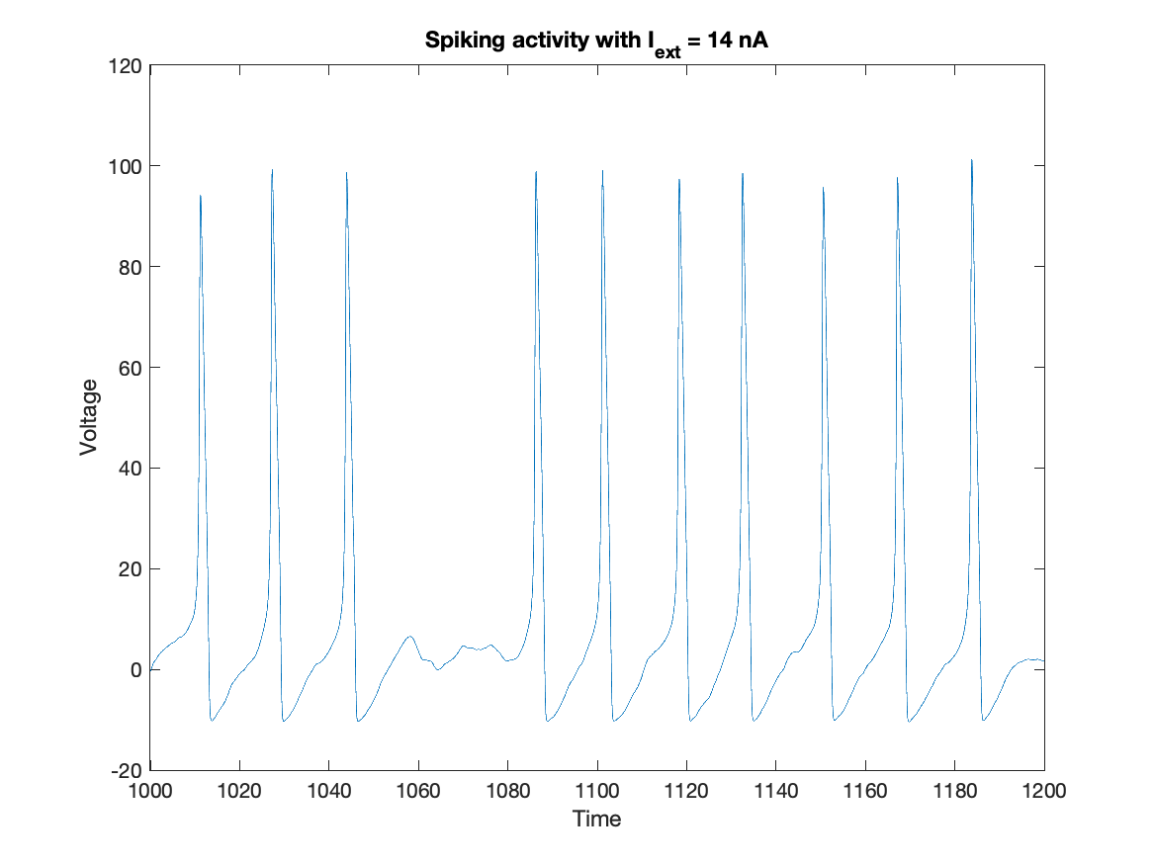 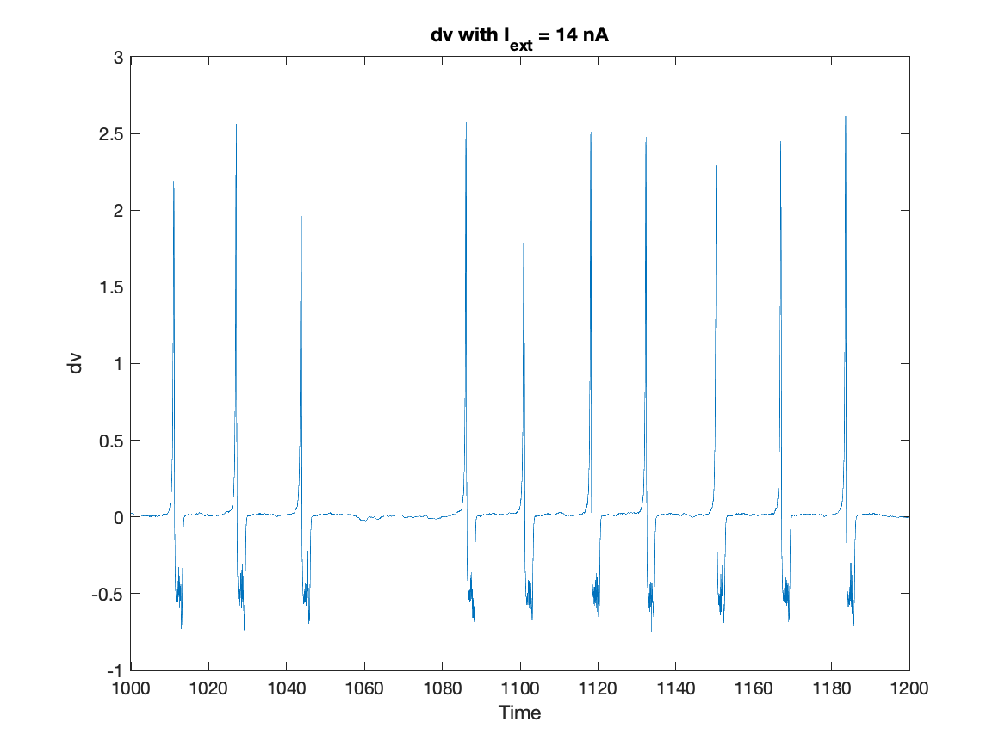

**Image C.1 The noise’s influence in model**

I measure the nosise and output change(dv) value. We can discover that the noise make more change in the depolorizing progress and the polorizing progress. So the polarization provide more robust for the Neuronal Model.

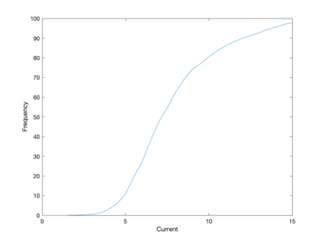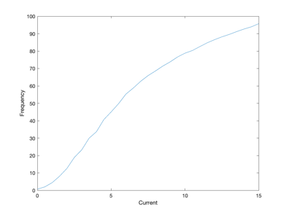

**Image C.2 The f-I curve with noise parameter 0.0001,0.0005,0.001**